CRM APPLICATION THAT HELPS TO BOOK A VISA SLOT

INTRODUCTION

OVERVIEW:

A visa slot management project is a system that is used to track and manage the availability of visa slots, which are appointments that are required for certain visa applications. It might be used by a government agency or a visa processing center to schedule and manage appointments with applicants.

PURPOSE:

Use:

**store customer and prospect contact information, identify sales opportunities, record service issues, and manage marketing campaigns.**

**ACHIEVEMENT:**

**The data in a CRM system can be used to learn what your best customers have in common so that you can then prioritize the leads that share the same traits.**

**PROBLEM DEFINITION**

**DESIGN THINKING:**

**EMPATHY MAP FOR VISA SLOT:**

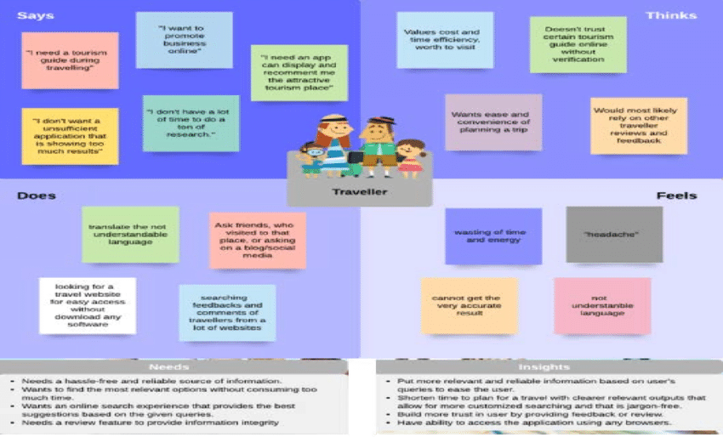

Ideation&Brainstorming Map: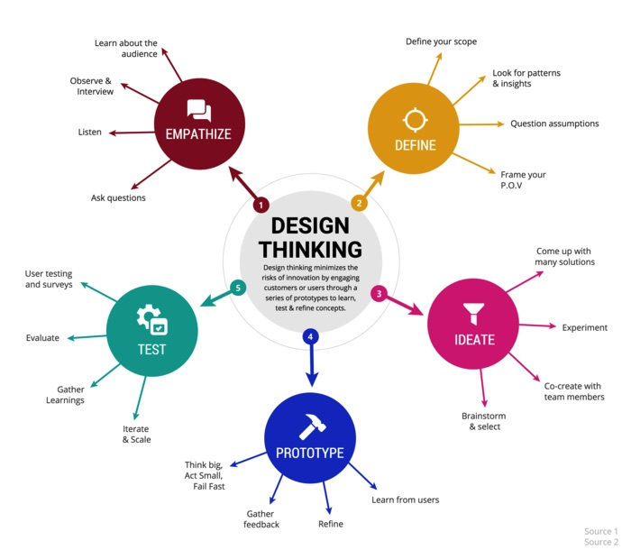

RESUlT:

|  |  |
| --- | --- |
| Object name | Field in the object |
| obj 1 | |  |  | | --- | --- | | Field label | Data type | | Contact number | Number | | Full name | Text | |
| Obj2 | |  |  | | --- | --- | | Field label | Data type | | Passport number | Text ‘ | | Permanent address | Text | |

Activity&ScreenShot:

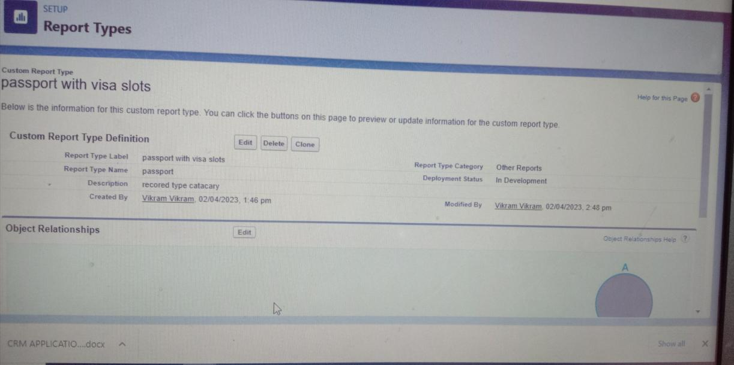

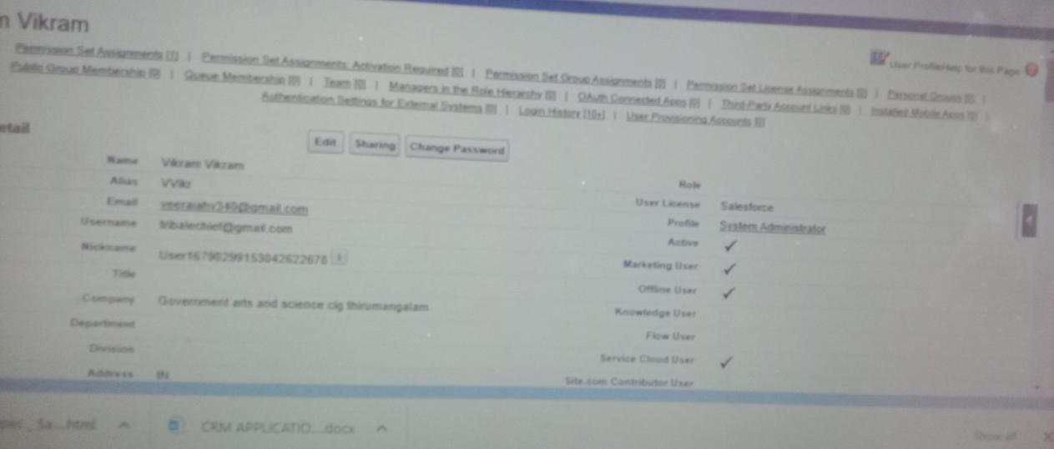

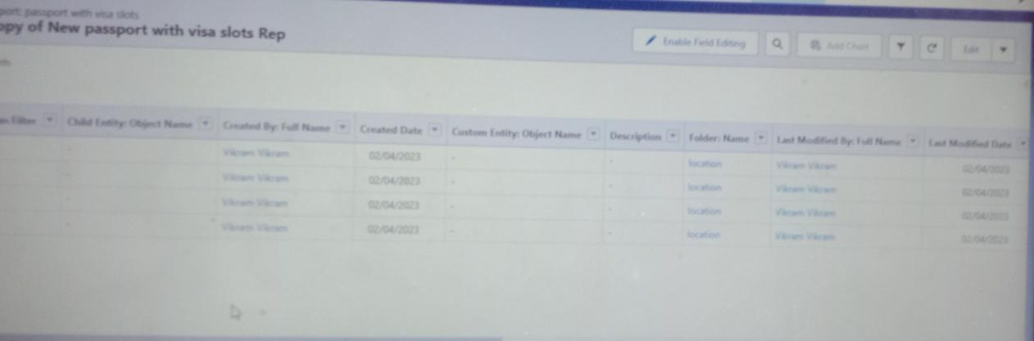

Trailhead profile public URL:

TEAM Lead : <https://trailbla>zer.me/id/rvikram14

TeamMember1:https://trailblazer.me/id/kasis11

TeamMember2:https://trailblazer.me/id/alagu2003

TeamMember3:https://trailblazer.me/id/kaviyarasan2003

ADVANTAGES&DISADVANTAGE:

* **t endanger the efficiency of the e-Visa service.**Identity theft**. Governments have great concerns regarding applicants' identities, since the visa application is submitted online and personal appearance at a visa office is not mandatory.**
* **biometric data, such as fingerprints and digital pict**Forgery of documents**. In case of e-Visas, supporting documents – such as proof of sufficient financial means, medical insurance or invitation letters – are submitted in digital format, thus increasing the risk of documents being falsified.**
* **Impossibility to collect biometric data**. While collecting ures, is possible when applicants have to personally appear at the visa office, the use of an e-Visa service does not allow this option.
* **Poor ICT infrastructure**. Authorities are afraid that the poor ICT infrastructure in some countries migh

DISADVANTAGE:

**2 year home residency requirement if funded by gov’t source, skills list or medical trainee -Category switch problematic within J program -Must**

**file with both Dept of Labor and DHS -Employer liable for return transportation if terminates employee prematurely -H-4 cannot work -WBs**

**and WTs cannot extend or change statuses -Payments limited to strict conditions -Requires extensive paperwork if applying a tax treaty.**

APPLICATION:

### Apply early

### Know the turnaround times

### Check off the documents list

### Be on time for your appointment

### Track your visa application

### Bonus tip!

Conclusion:

Summary refers to the concise statement or account of the key points of a text, research or essay. The conclusion is that section of the text, essay or book which serves as the final answer to the research question. To outline the vital points.

FUTURE SCOPE:

**1 the time yet to come. 2 undetermined events that will occur in that time.**